**Import Export Code**

The import export code allotted to a corporate is evidence of a company’s ability to either import or export goods. It is a code provided upon registration and verification and is mandatory to conduct trading activities beyond national borders.

**Aim:**

To obtain the Import Export Code particulars of a company. Not all companies would have an import/export code. Also, some companies have an import export code that is alphanumeric while others have an IEC code that is the PAN number of the company.

This project proposes to do the following:

1. verify IEC availability using PAN number of companies;
2. capture the relevant details available on successful searches

We can split the project into 3 parts:

**Part I:**

input the pan number in the **DGFT website** and check for the output/result. This website should give us an IEC number as well as a registration date and validity status.

* If successful, we may mark that PAN as verified and collect the details.
* If unsuccessful, we may select that PAN for verification in Part II and Part III.

**Part II:**

for companies that do not provide a result in Part I, input the pan number in the **ICEGATE Check IE Code/BIN Status** website and check for the output/result. This website should give us an IEC number as well as a registration date and validity status.

* If successful, we may mark that PAN as verified and collect the available details.
* If unsuccessful, we may select that PAN for verification in Part III

**Part III:**

for companies that do not provide a result in Part I or Part II, we may input the PAN number in the **ICEGATE Registration Verification** website to verify if the company is an importer/exporter and if it has an IEC code. If a company provides a result at **ICEGATE Registration Verification**, it shows that the company is registered as an importer/exporter but does not use the PAN as its IEC code.

- if successful, we may mark that company as an importer/exporter NOT using PAN as its IEC Code

- No particulars of the PAN (allotment date, validity etc.) would be shown by this website when result is successful

*\* Probe would provide the PAN numbers that need to be checked through all the parts.*

**Source for Part I:**

DGFT: <https://www.dgft.gov.in/CP/?opt=view-any-ice>

Step 1: Click on “View any IEC”

Step 2: enter the PAN number provided in the “Enter Importer/Exporter Code” section

Step 3: enter whole or part of the company name

Step 4: enter the Captcha code and click on View IEC

**Successful IEC:**

**Unsuccessful or No IEC Code:**

**Source for Part II:** <https://old.icegate.gov.in/EnqMod/>

**Step 1:** Enter the PAN number in the “Enter the IE Code” field

Step 2: Enter the captcha

Successful Result:

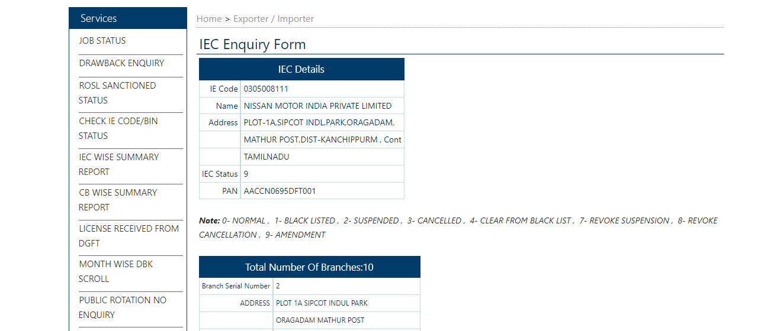

**Unsuccessful Result:**

**Source for Part III:** <https://old.icegate.gov.in/EnqMod/USER_PANDetails_action>

Step 1: enter the PAN number of the company in “Enter PAN No.” column

Step 2: enter the captcha and click on submit

**Successful entry:**

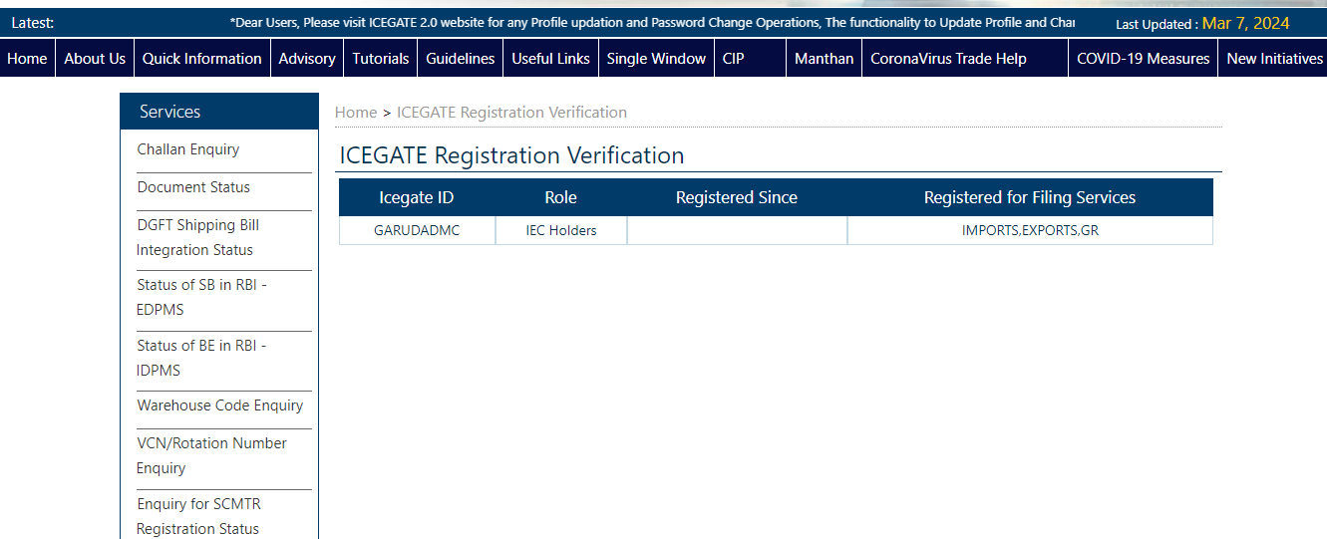

**Unsuccessful entry:**

